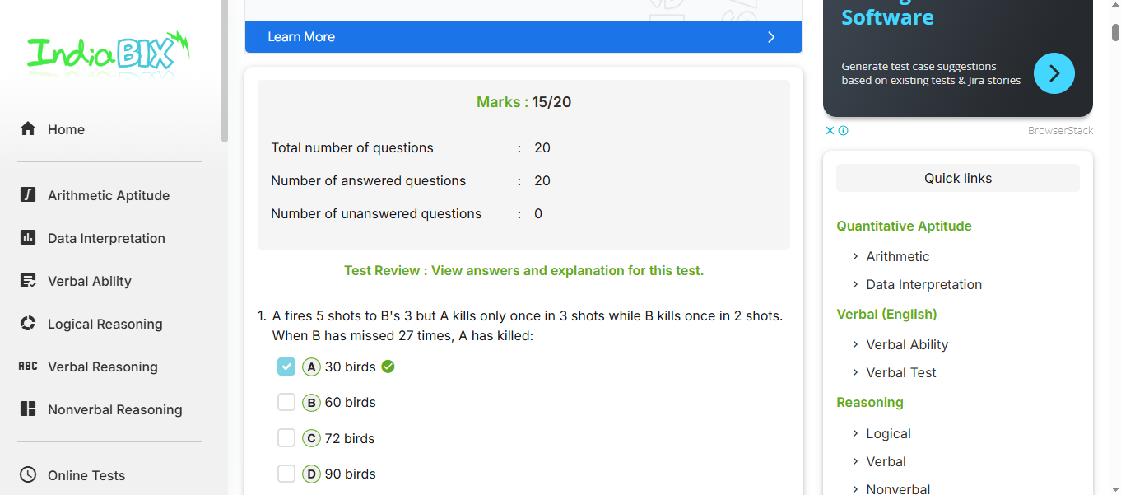

https://youtube.com/shorts/hRxw8wzdEPs?feature=share